Skyview Networks’ Traffic Site Manual
Skyview affiliates will receive all traffic instructions and report clearance through Skyview Networks’ web portal. This manual detail how to access and utilize the portal for all your traffic needs.

Getting Started:

When using the Skyview Traffic site, always use the web browser Google Chrome for optimum user experience. The link to the traffic website is:

traffic.skyviewnetworks.com

We recommend adding this URL to your favorites bar or creating a shortcut on your desktop to quickly access the site.

You will be prompted at first login to change the default password to a custom password.

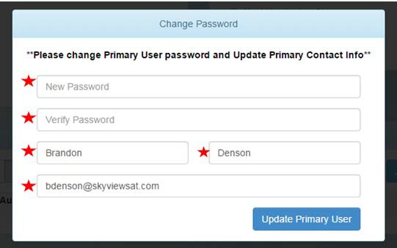
Next, you will be prompted to enter the following information to get started:

After doing so, click the “Update Primary User” button. You will then be directed to the homepage as seen below: 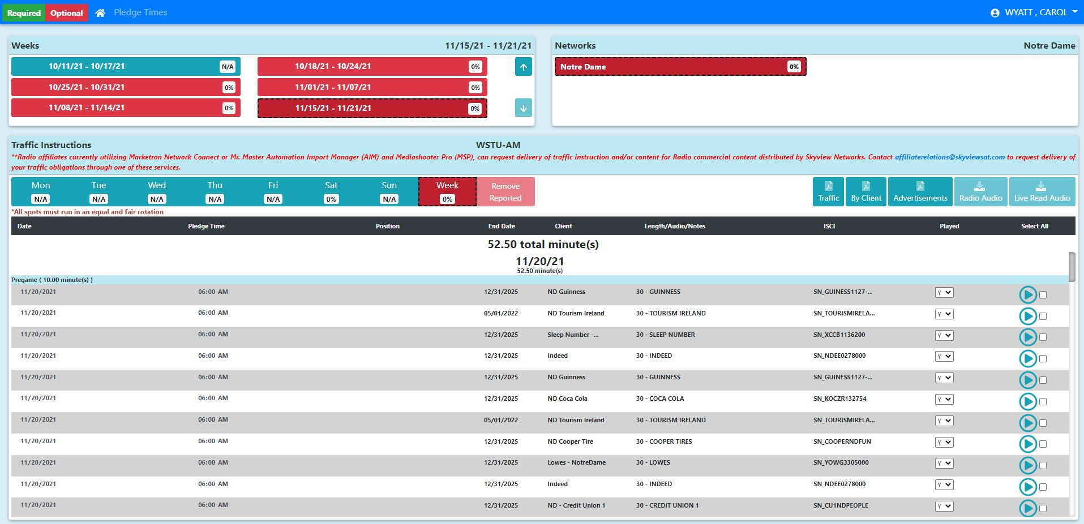
Once here you will select the week and network you would like to view.

After you select the week and network, the Inventory will populate.

Downloading Spots:

- You may filter the spots displayed by clicking on “Week” or any of the single days. This will show you everything for the date range selected.
- You can select all spots in the list by clicking on the text “Select All.”
- You can select specific spots by clicking on the corresponding radio button.
- If you would like to listen to a spot, click on the blue download button.
- Once all the desired spots have been selected, click the button labeled “Download All Audio.” This will save all selected spots in a zip folder.

1
2

3

4

Saving/Printing a PDF Version

- Click the button labeled “Traffic.” Make sure you have your pop‐up blocker disabled as it will open in a new window. Choose the option “Always allow pop‐ups from
- You can then print or save the PDF by using the highlighted tool:
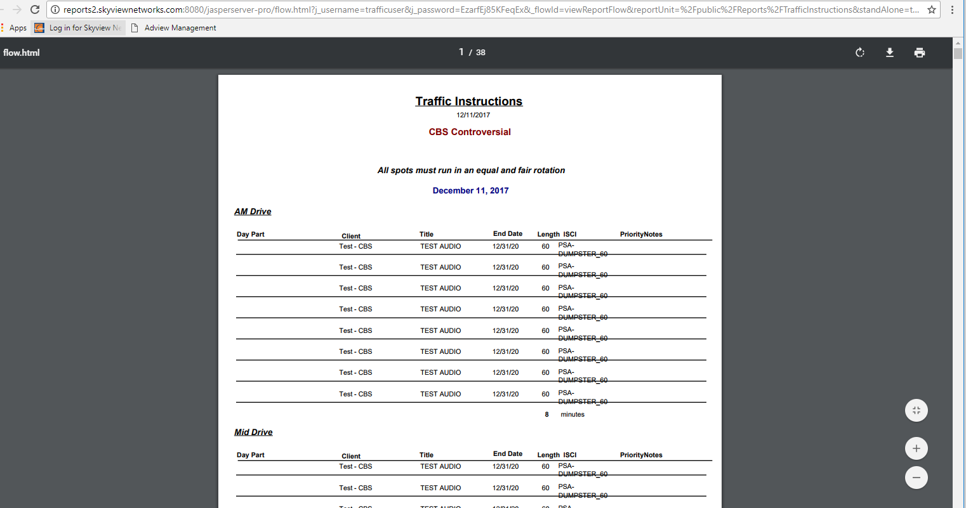

Submitting Play Times:

- Select the week.
- Select the network.
- The “Pledge Time” on future dates is a tentative time.
- Under the “Played” column select “Y” for yes or “N” for no to indicate if the spot played.
- Click “Submit Affidavit”
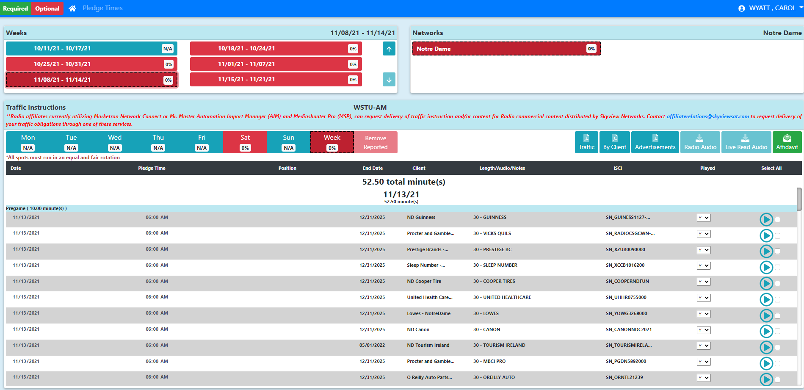
5
2
1
3
4

- If there is a difference in the pledge time and the actual play time, click “Edit Times.”
- Type in the correct time.
- All spots, on that given day or week, will be submitted once user has verified everything is good and then clicks on the button “Submit Affidavit”.
6

7
8
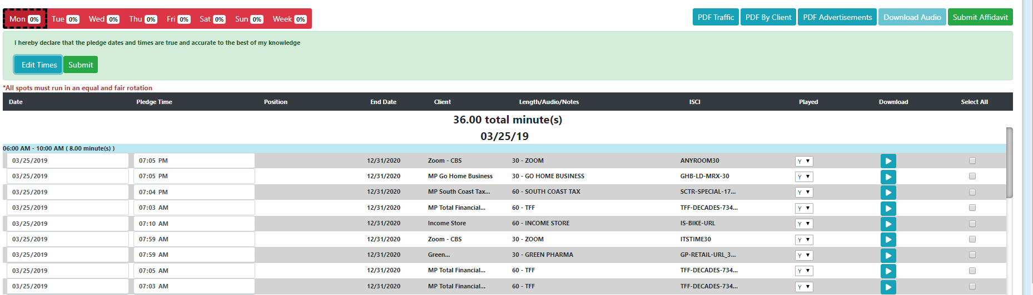

- After you submit, you will be unable to edit times.

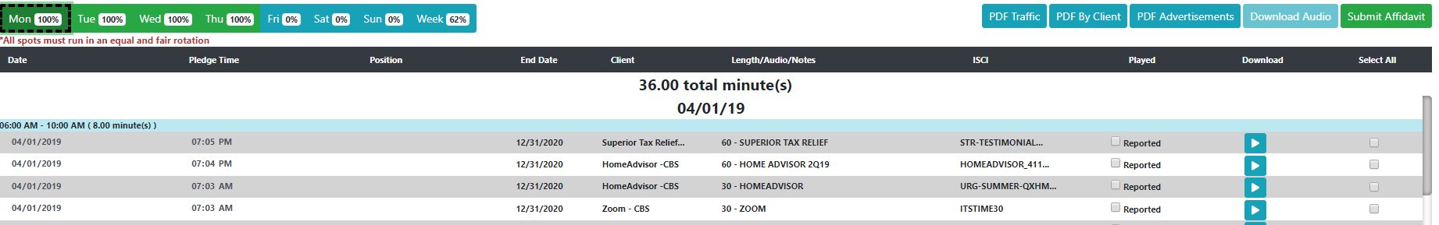
- After a spot is submitted, it will show the status as “Reported” in the “Played” column.

Once reported, if desired to change time again, select the check box next to the instruction that has been reported and you will be able to change desired instructions time. Then select Submit Affidavit and submit like normal and only those reported and checked will be submitted.

Submitting Optional Play Times:
Should your station air commercials above your required allotment, there is a feature to submit times for these commercials.
In the upper left corner, there are two buttons for Required Inventory and Optional Inventory.
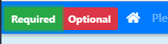
To view Optional Inventory:
- Click the "Optional" button (the Optional button turns green when selected)
- Note the list of inventory changes to commercials aired in overnights and optional weekend inventory.
*Submitting air times and setting pledge times for these commercials is the same process for the Required Inventory noted in the traffic manual when the Optional feature is selected.

Pledge Times/Barter Spots

- Barter spot position in the grid view and in the reports.
  - The field titled “Position” will display information if the barter spot is associated with special content, such as Dave Ross, Reporter’s Notebook, or ET Radio Minute. If it is empty, it is a traditional barter spot and is associated with your regular affiliation package.
- Edit your pledge times.
  - If you air your barter spots for each day at a particular time, you now have the ability to edit the default pledge time (which is the network feed time). Simply click on the “Change Pledge Times” button located near the Home button in the upper Left corner of the page:
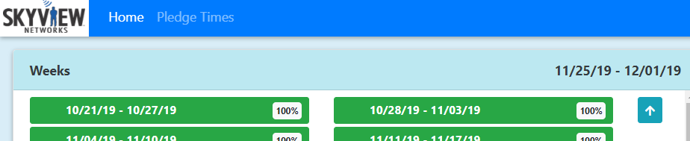
a

  - Once there, you can see your barter spot break by day of week and by feed time.
You can further filter by day of week and /or by Network
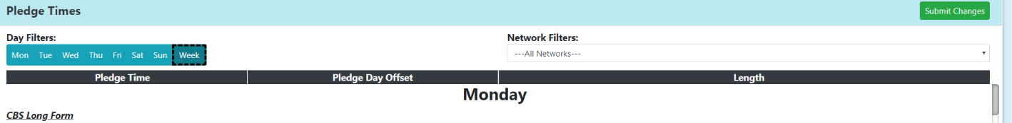
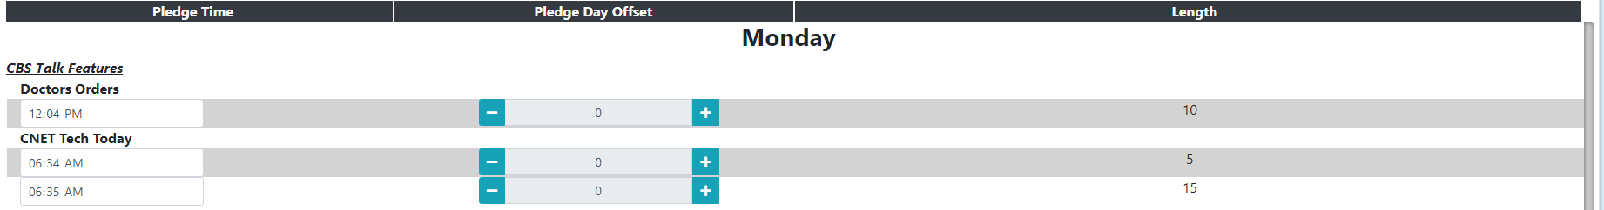
  - Simply edit the times by clicking in the text box in the Pledge Time column, enter your preferred/regular pledge time and then click the green “Submit Changes” button in the upper right of the Pledge Times grid. Once you are done, select “Home” and you will be taken back to the main traffic instructions page with each barter spot updated with your new pledge times.

- You can adjust the date of a spot in the case of a make good.
  - Should you need to make good spots from earlier in the week, you can now adjust the date of playback when you click on “Submit Affidavit” and then click “Edit Times.” It will automatically record that spot as a make good spot in the system and no further input is required.

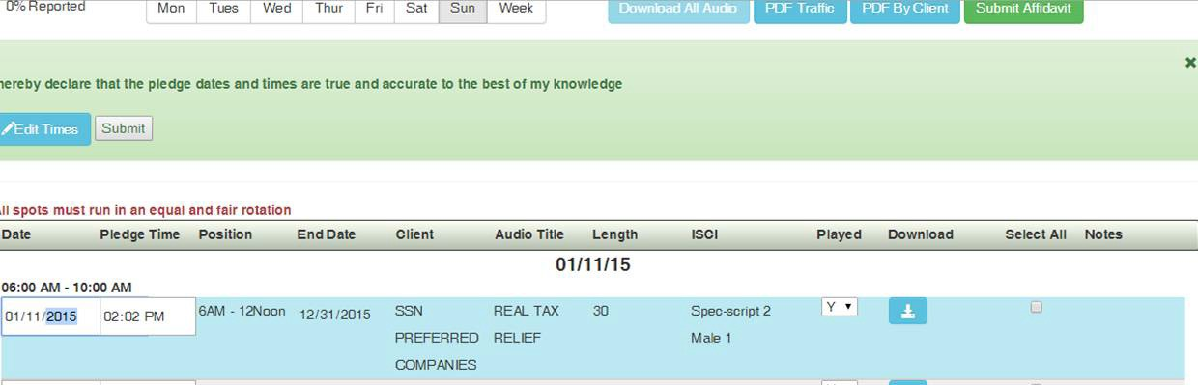

- You can now specify a reason for missed barter spots.
  - Should there ever arise a situation where a barter spot was missed or was not acceptable due to legal requirements with your station/state, you can specify by changing the “Played” column drop down to “No” and enter up to 400 characters explaining why the spot unable to be played.

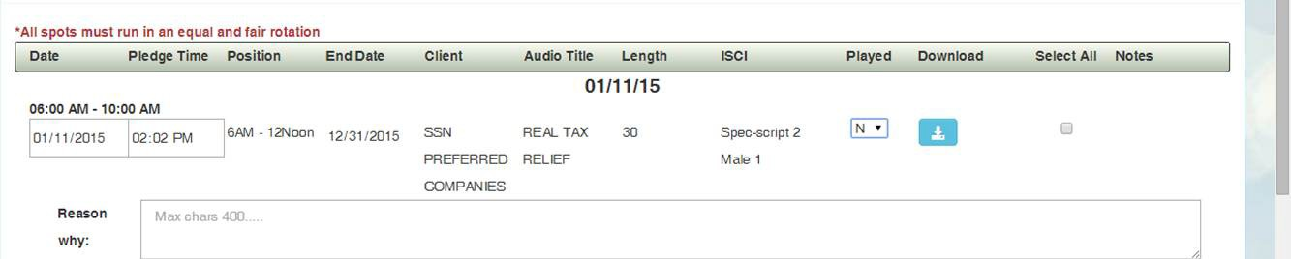

Removing Reported Spots

You can remove submitted spots by Day or by Week.

The “Remove Reported” button will remove all submitted spots for the range selected.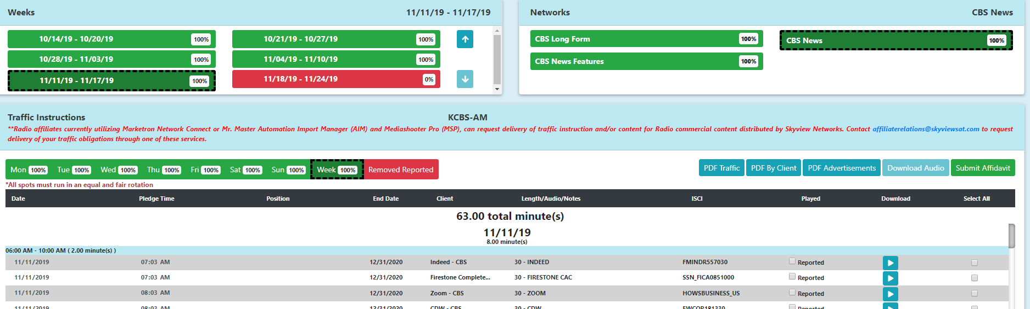

After clicking Remove Reported, it will confirm the date range you wish to remove.
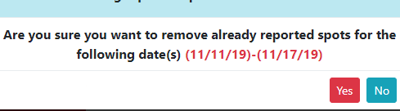

Questions? If so, please reach out to Skyview Networks’ Network Operations Center for further assistance. Network Operations is available 24/7.

Email: affiliaterelations@skyviewsat.com

Phone: (480) 503‐8727 or toll free at (877) 503‐8910

